1. Go to amazon and create a new account
   1. 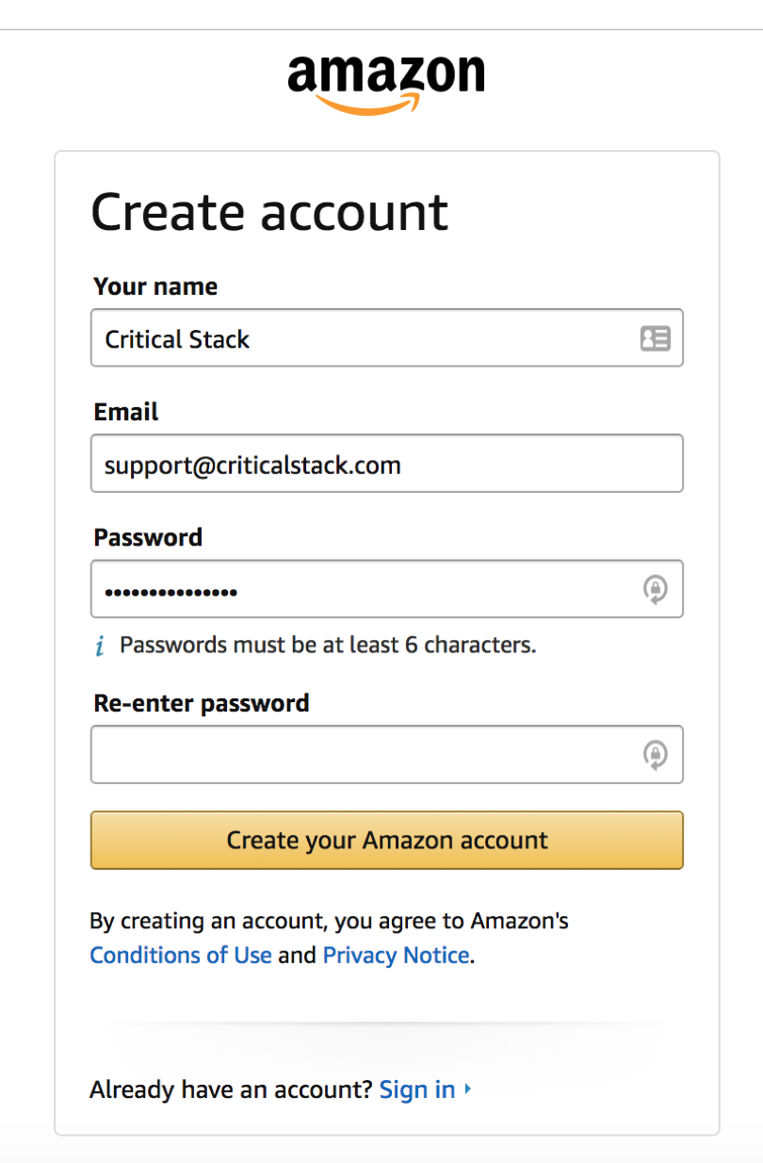
2. 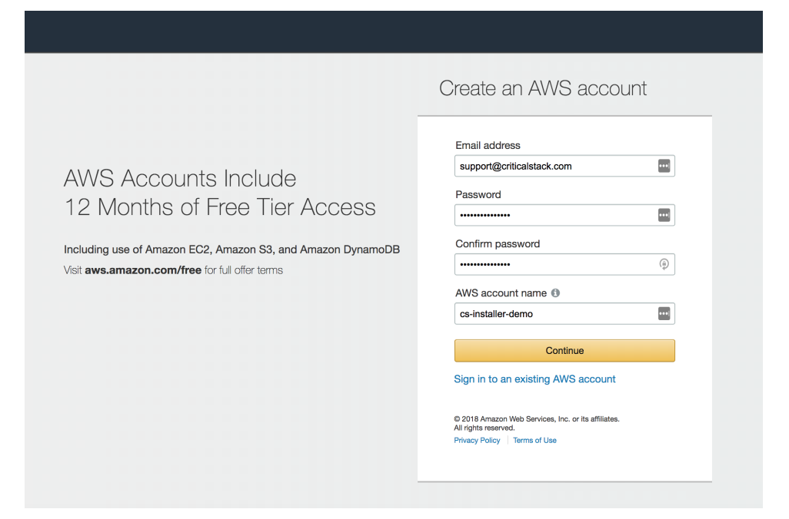
3. 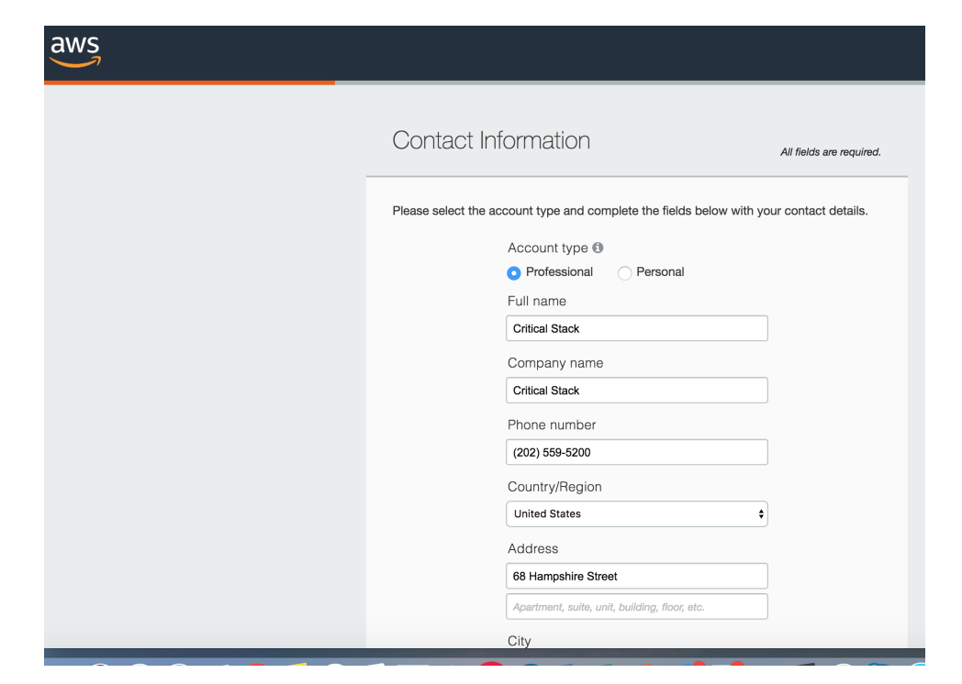
4. 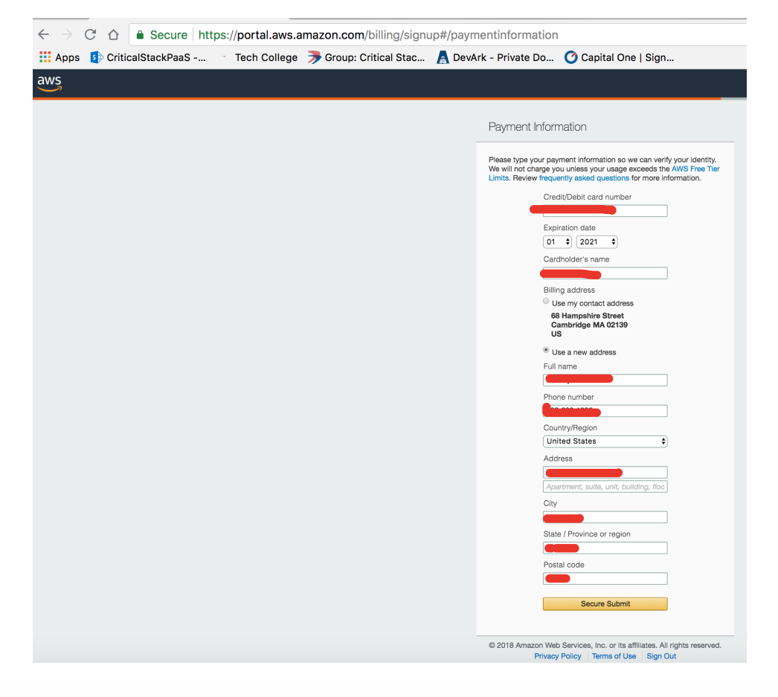
5. Verify account
   1. 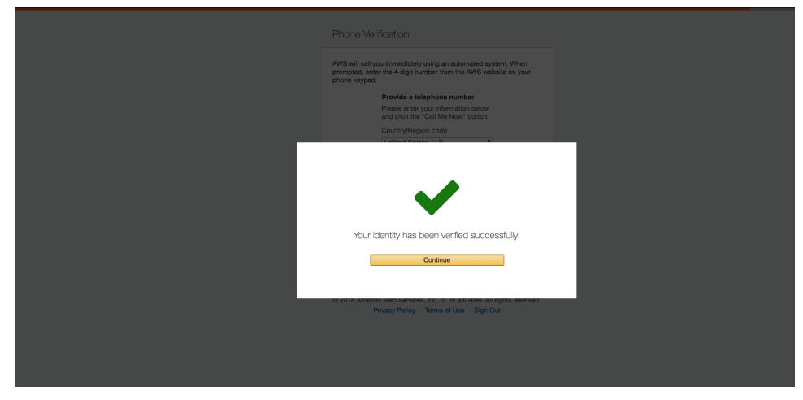
6. Sign in to your account
   1. 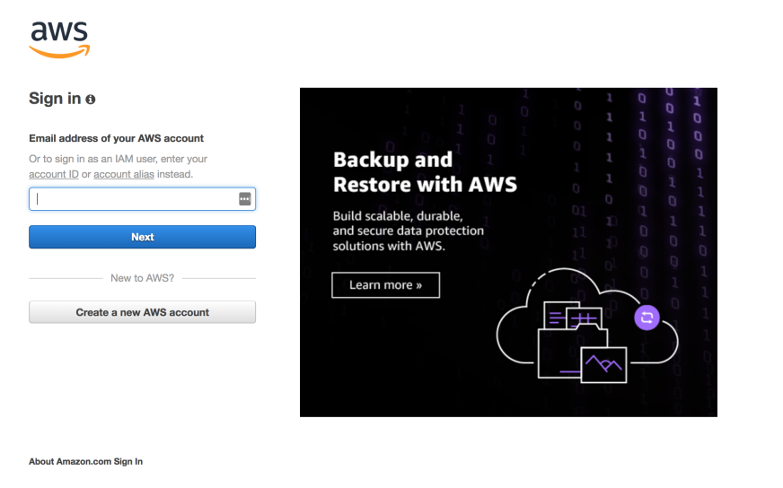

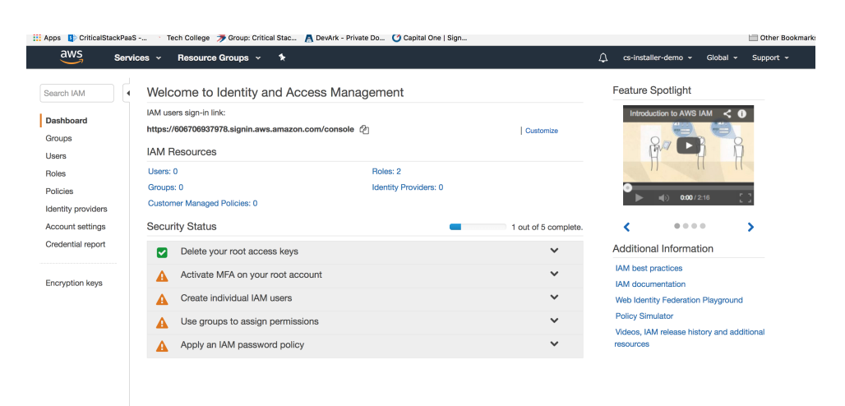

1. Type IAM under AWS Services to be taken to the dashboard
2. Click “Users” from navigation
3. Create a user by selecting ->
   1. 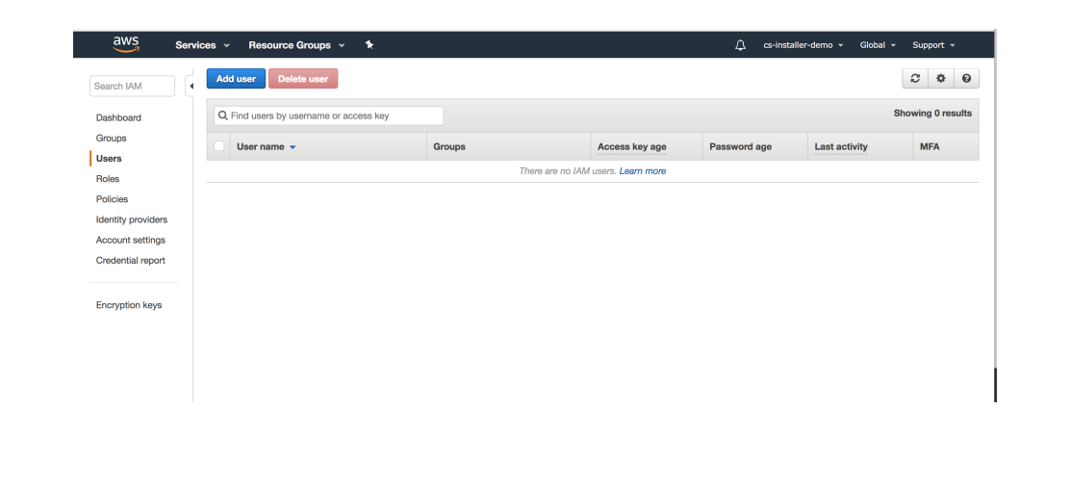
   2. Choose Programmatic Access for Access Type, then -> Next: Permission
   3. 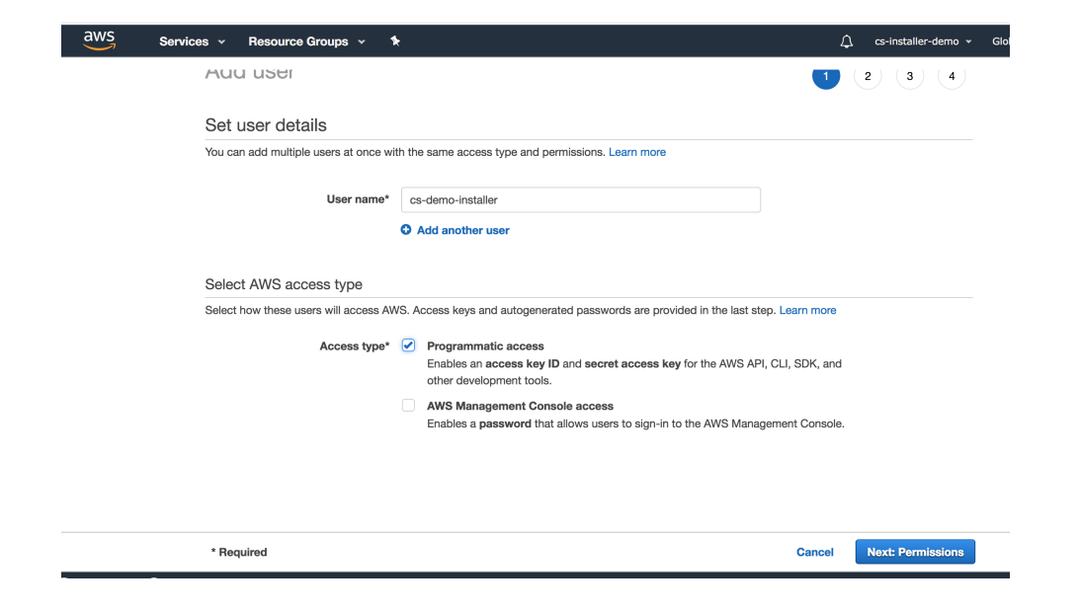
   4. Create a new group for permissions with admin access by selecting -> Create group then -> Next: Review

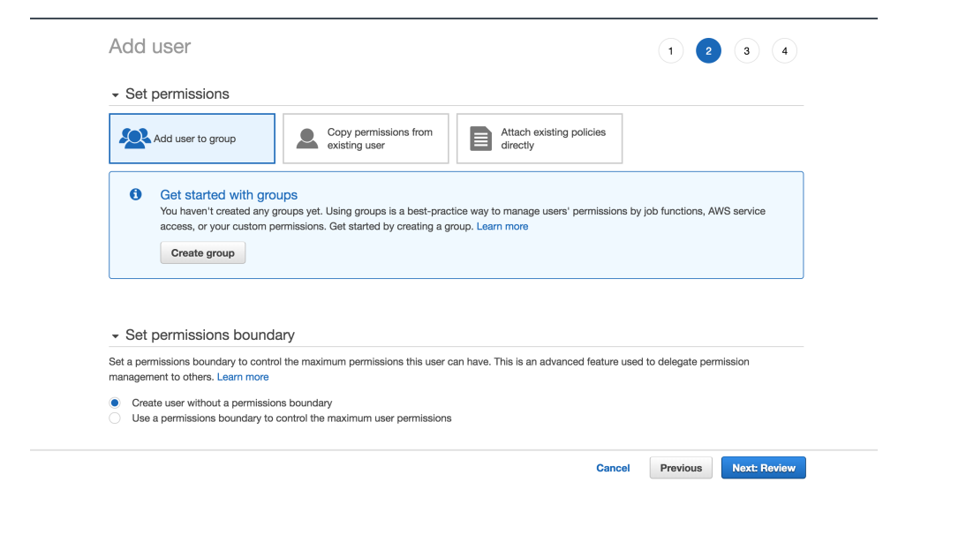

* 1. Create a new group like “Admin” and select AdministratorAccess from the Policy Name list:

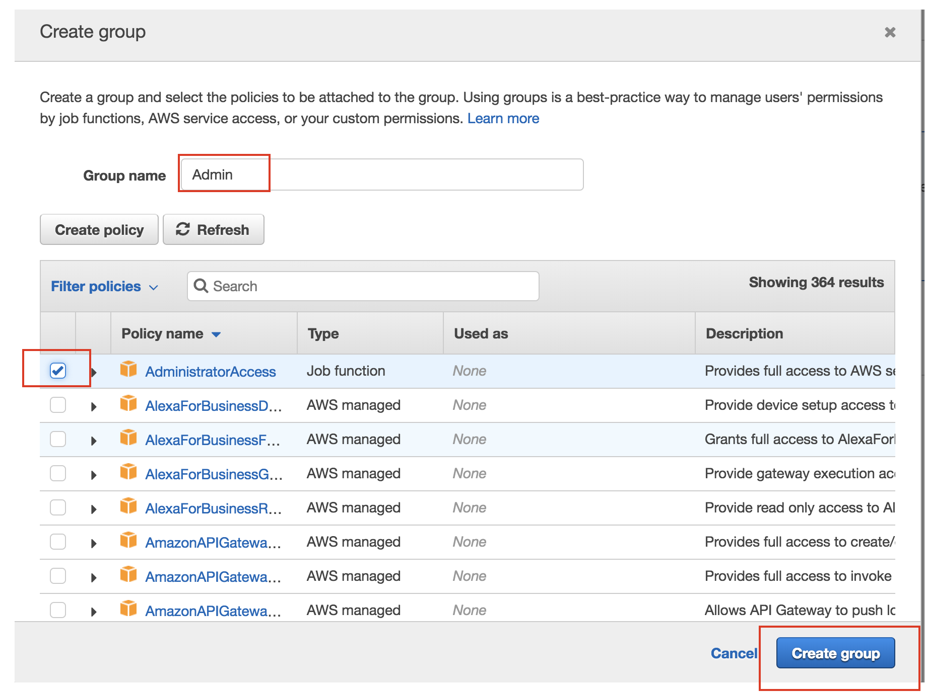

* 1. That’s it! Copy the User’s Access Key and Secret to clipboard and use that in the CS installer
     1. 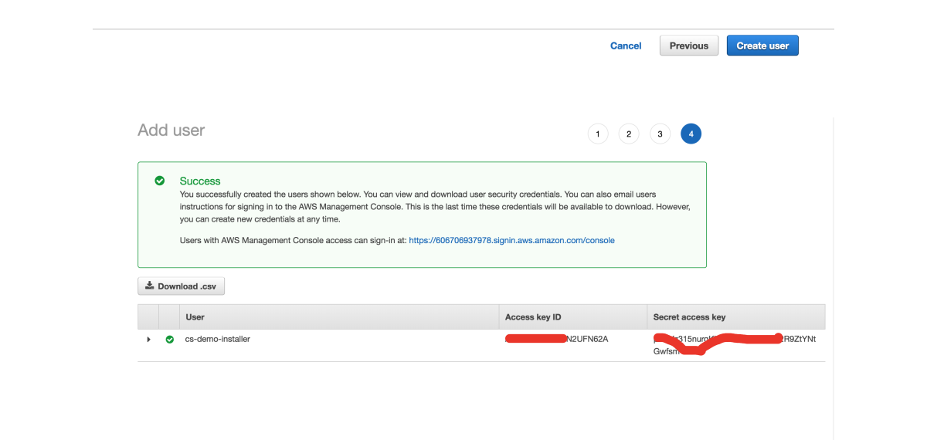
     2. Need Info on how to find these key after creation